[1]

Project: Research on *Broadband Planar SIW Cavity-Backed Slot Antennas Aided by Unbalanced Shorting Vias*

Ji Chenqing: Penta-mode SIWCBS Antenna designing &unbalanced shorting vias exploration

Ji Xianglin: Quad-mode SIWCBS Antenna designing & theory exploration

Zhang Juntao : Penta-mode SIWCBS Antenna designing &another paper exploration

*Abstract*—In this report, two types of SIW CBS antennas are presented and discuessed. These two antennas are aided by unbalanced shorting vias and have much wider bandwidth compared with traditional ones. We use HFSS to model two types of antennas and learn why broad band is achieved. Then, the influences of the special structures on antenna are shown separately, especially the influence caused by the unbalanced shorting vias. Moreover, a typical SIW CBS antenna is also modeled, which help us to understand the improvement caused by this special design

*Index Terms*—SIWCBS，wideband antenna，unbalanced shorting vias

# INTRODUCTION

S

ubstrate integrated waveguide (SIW)-like cavity backed slot (CBS) antennas have been widely investigated for various applications including satellite communications and wireless communications recently because of their outstanding advantages of easy integration with planar circuits, low profile, and excellent directional radiation performance. [1]

In our project paper provided, two types of substrate integrated waveguide (SIW) cavity-backed slot (CBS) antennas are proposed for bandwidth enhancement, that is QUAD-MODE SIW CBS antenna and PENTA-MODE SIW CBS antenna.

In our project, we focus on the modeling of these two antennas and the simulation of various important parameters. In addition, for penta-mode SIW CBS antenna, we also explored the antenna performance after excluding various shorting vias. In addition, we also found a detail: In the original paper, the shorting vias around the rectangular patch were symmetrical in the real object during the drawing process, but the author did not place shorting vias around the rectangular patch symmetrically in the modeling process, which is also the focus of our research in this project. Finally, we modeled another type of quad-mode SIW CBS antenna through another literature similar to this paper and compared with the modeling results of quad-mode SIW CBS antenna in this paper. Finally, our simulation results show that the maximum bandwidths of quad-mode SIW CBS antenna and penta-mode SIW CBS antenna can reach 18.8% and 20.7% respectively.

# QUAD-MODE SIW CBS ANTENNA

Quad-resonance SIW CBS antenna is proposed using a cross-shaped slot and loading unbalanced shorting vias. Additional half-TE120 mode is successfully excited along with three other independent modes including half-TE110 and odd and even TE210 modes.

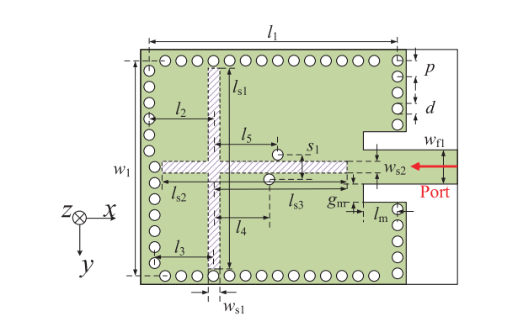

Fig. 1. Model in paper

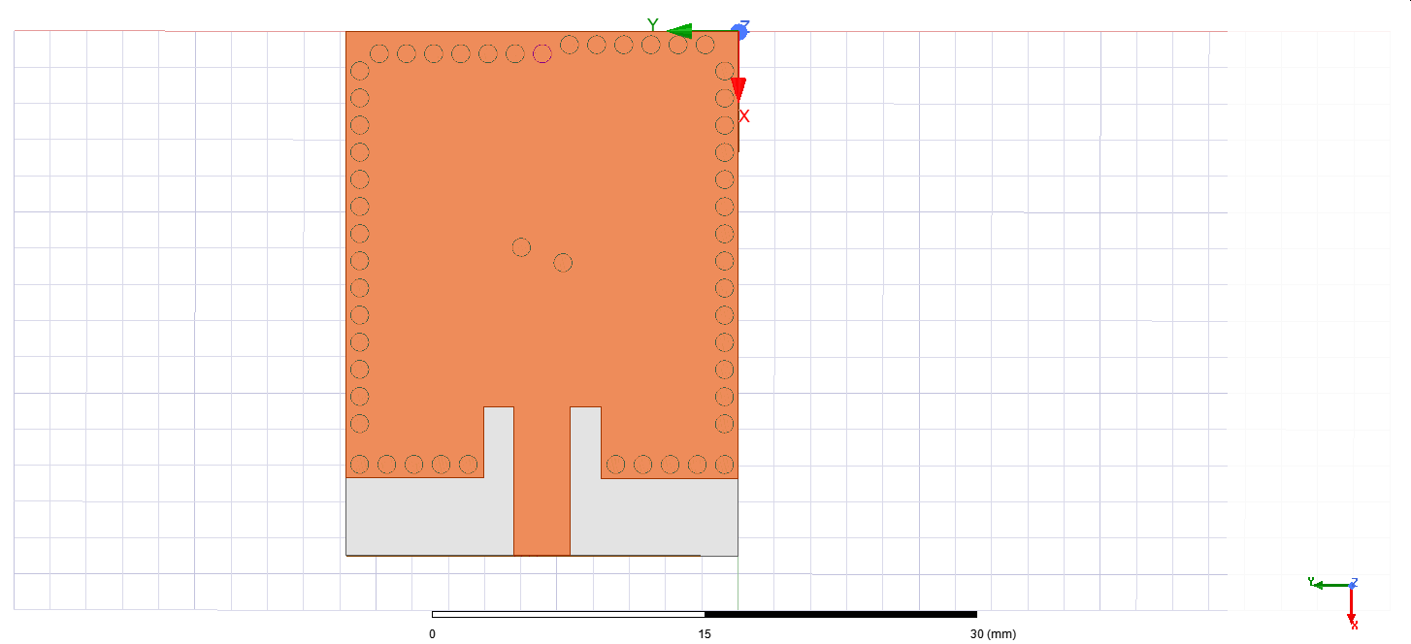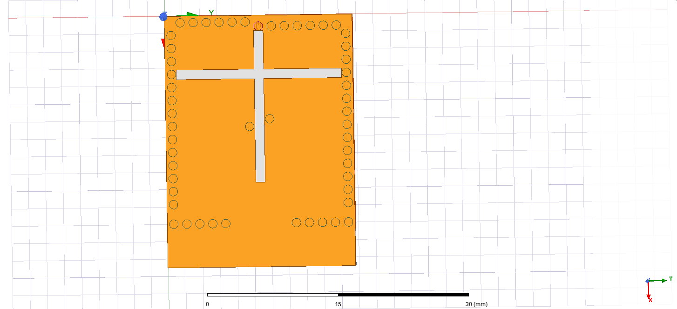

Fig. 2. Our model in HFSS

According to the S11 parameter, (Fig.3) we can roughly calculate the antenna bandwidth, which is: The left figure: 20.8% (8.9 -- 10.9 GHz) and the right figure:18.8% (8.75-10.73 GHz). Therefore, from the point of view of the number of resonant frequency points and antenna bandwidth, our simulation results are basically consistent with those in the paper.

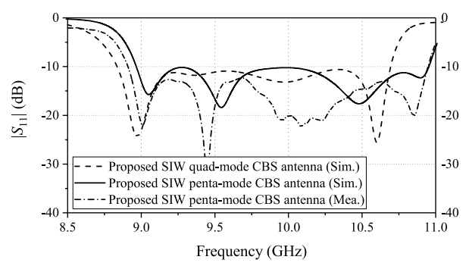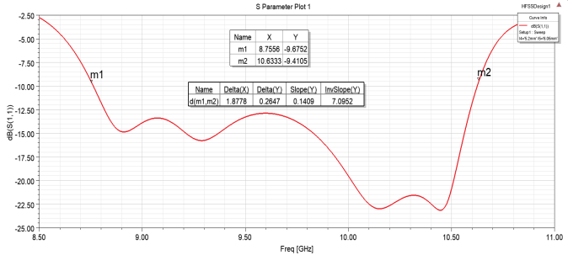

Figure. 3 S11 parameter

Above: Result in paper; below: Result in our work

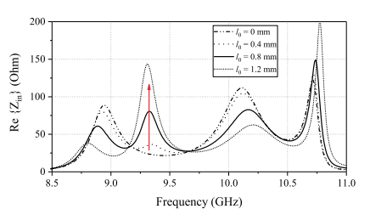

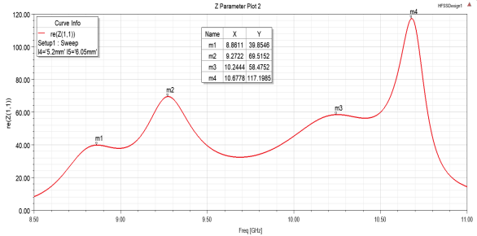

Fig. 4. The real part of input impedance

Above: Result shown in paper;

Below: Result in our work

m1:(8.8611GHz, 39.8546Ω) m2:(9.2722GHz, 69.51526Ω)

m3:(10.2444GHz, 58.4752Ω) m4:(10.6778Hz, 117.1985Ω)

As can be seen from the figure 4, the position of the peak value of input impedance in our simulation results is basically consistent with that in the paper.

From the image of radiation efficiency (Fig 5), our antenna can maintain radiation efficiency above 0.96 over a wide range of bandwidth, which is a big advantage of this antenna.

According to the radiation pattern(figure6&7), the simulation results of our simulated radiation graph at two resonant frequency points (9.3GHz and 10.2GHz) are basically consistent with those in the paper.

As for Electric Field Distributions, the simulation results of the electric field distribution of the four resonant modes are basically consistent with the results in the paper, which once again shows the correctness of our simulation results.

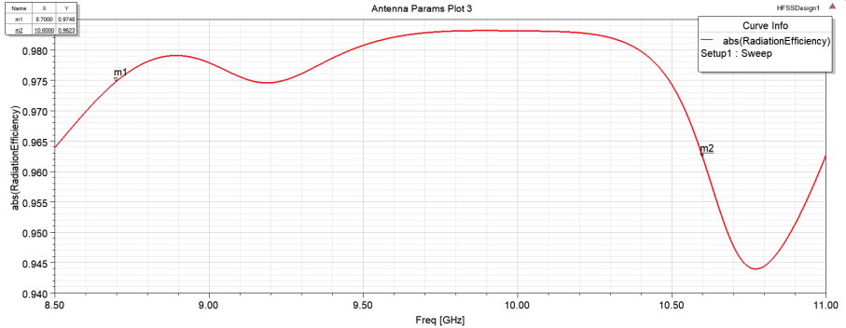

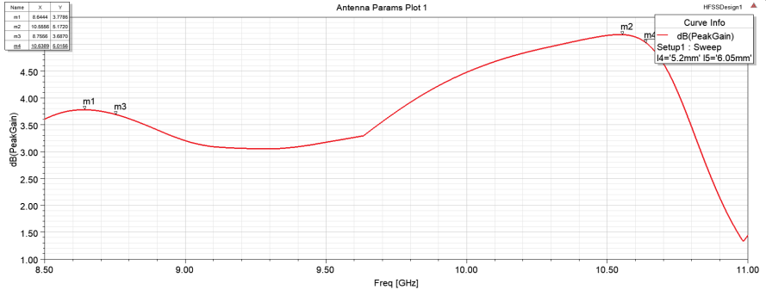

Fig. 5. Radiation Efficiency && Gain

Above: Max Radiation Efficiency 0.986 around 10GHz

Below: Max Peak Gain 5.17 dB at 10.55GHz)

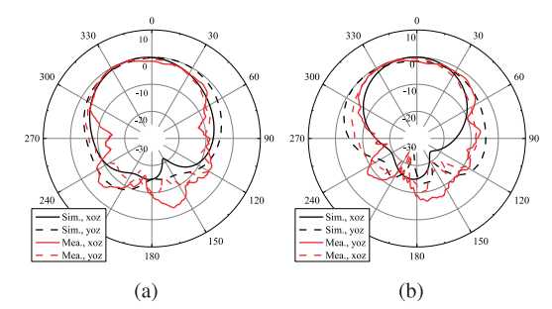

Fig. 6 Radiation Pattern (Gain Total) in the paper

(Left: 9.3GHz; Right:10.2GHz)

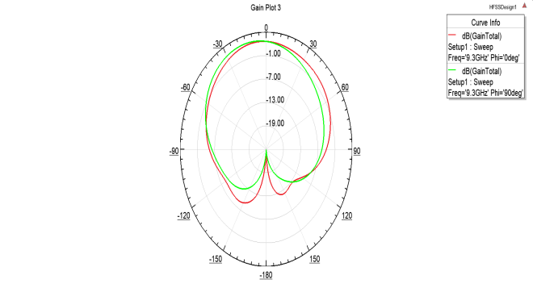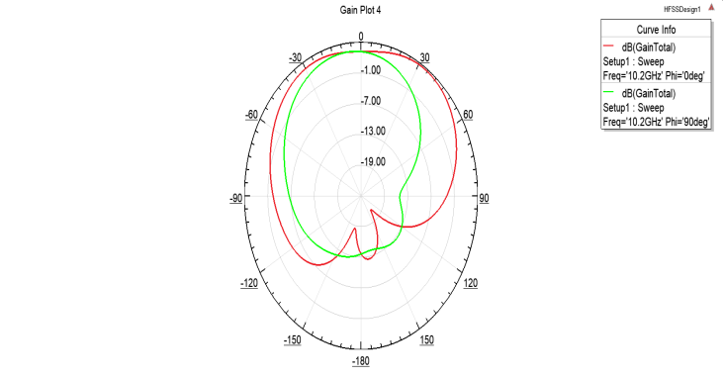

Fig. 7 Radiation Pattern (Gain Total) In our model

(Left: 9.3GHz; Right:10.2GHz)

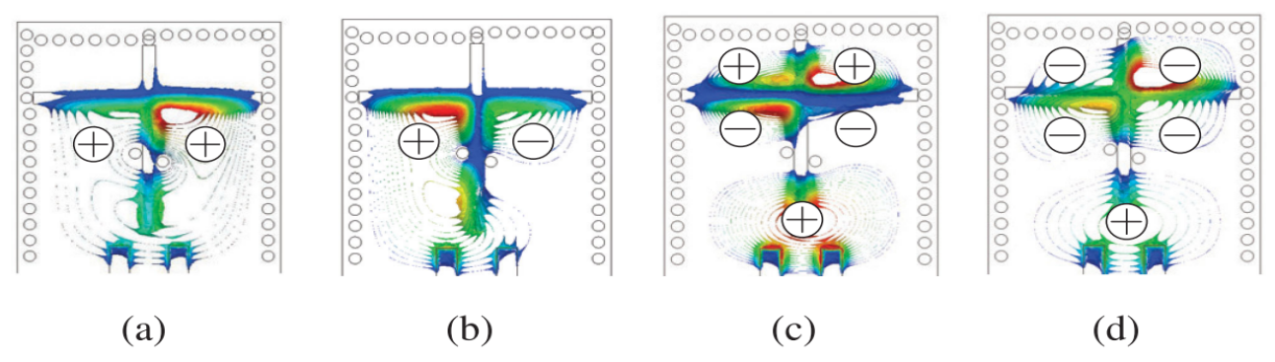

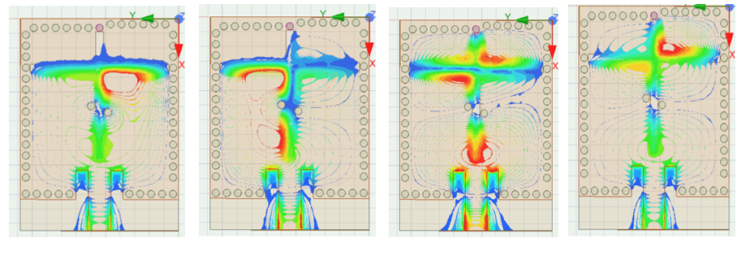

Fig. 8. Electric field distribution

From left to right,

Freq. :8.9, 9.3, 10.2 and 10.7 GHz

Mode: half-TE110, half-TE120, odd TE210and even TE210 mode

# PENTA-MODE SIW CBS ANTENNA

Penta-resonance SIW CBS antenna with a cross-shaped slot is proposed, in which two pairs of shorting vias are loaded. Two additional hybrid modes of half-TE210 and half-TE120 modes are introduced along with three other independent modes including half-TE110 and odd and even TE310 modes. 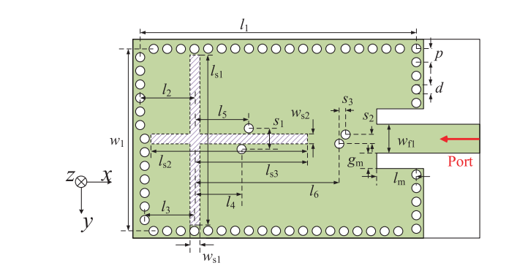

Fig. 9. Model in paper

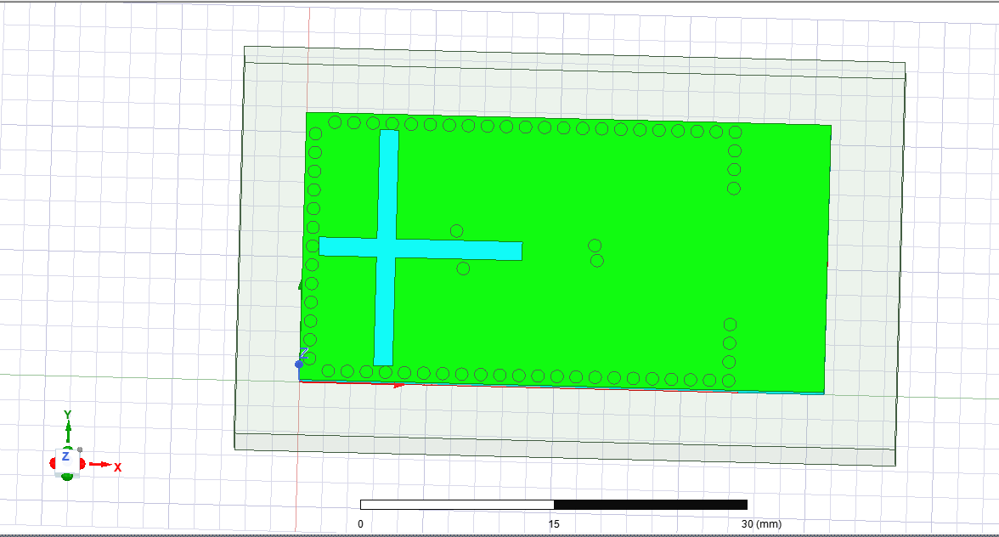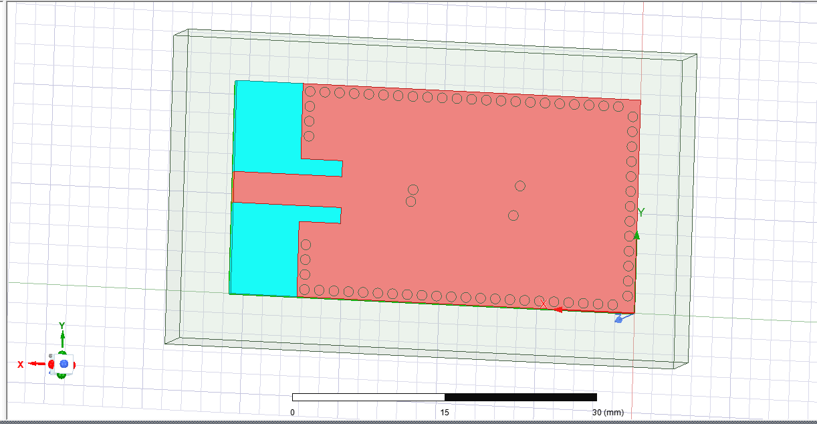

Fig. 10. Our model in HFSS

It is worth noting that in this paper, the shorting vias around the rectangular patch are asymmetrical when the author models it. However, when the plate is made, the shorting vias around the rectangular patch are symmetrical. Therefore, we explored both cases during modeling. The case shown above is that shorting vias around the rectangular patch is symmetric, while the asymmetric case will be explored in the fifth part.

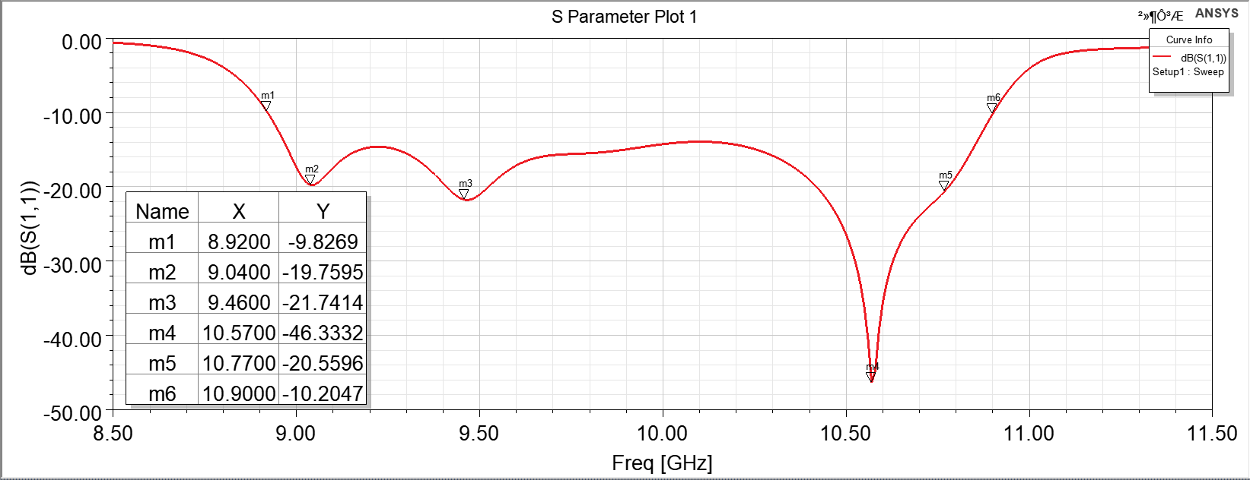

Figure. 11. S11 parameter

Above: Result in paper; below: Result in our work

According to the S11 parameter(Fig 11), we can roughly calculate the antenna bandwidth, which is: The left figure: 20.8% (8.89–10.95 GHz) and the right figure:20.7% (8.92–10.90 GHz). Therefore, from the point of view of the number of resonant frequency points and antenna bandwidth, our simulation results are basically consistent with those in the paper. At the same time, we can see that compared with the simulation of quad-mode antenna, penta-mode antenna has more resonant modes, so its bandwidth is higher than that of quad-mode antenna.



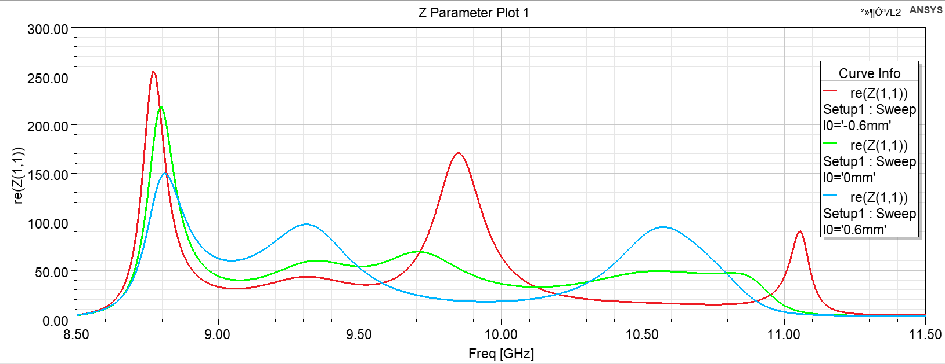

Fig. 12. The real part of input impedance

Above: Result shown in paper;

Below: Result in our work

In Fig .12, We can see that when l0 changes from -0.6mm to 0mm, between 9.50GHz and 10GHz, the original half TE210 mode will be replaced by two separate hybrid resonant modes. Since increasing resonant mode can improve antenna bandwidth (we can also draw this conclusion in the later exploration section). Therefore, we finally use l0 = 0 mm (corresponding to l0 = 0.6mm in the paper) to balance the trade-off between reflection performance and bandwidth.

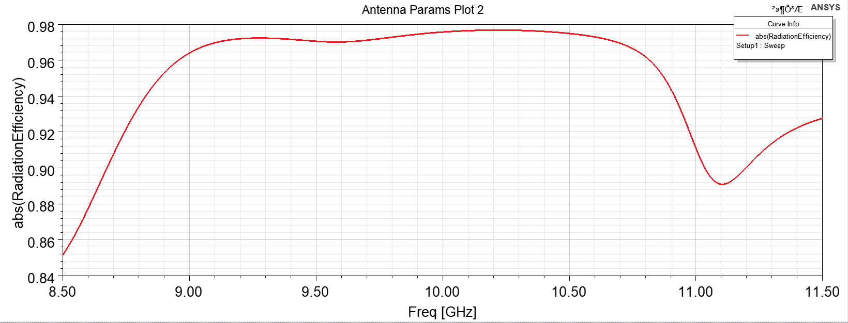

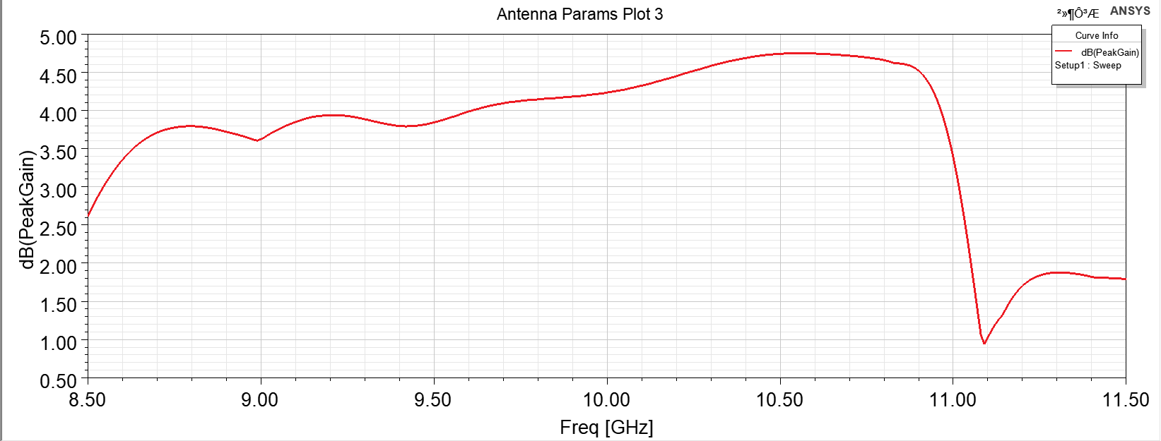

Fig. 13. Radiation Efficiency && Gain

Above: Max Radiation Efficiency 0.9768 around 10.21GHz

Below: Max Peak Gain 4.745 dB at 10.58GHz

As can be seen from the image of radiation efficiency, our antenna can maintain radiation efficiency above 0.92 over a wide range of bandwidth, which is a big advantage of this antenna.

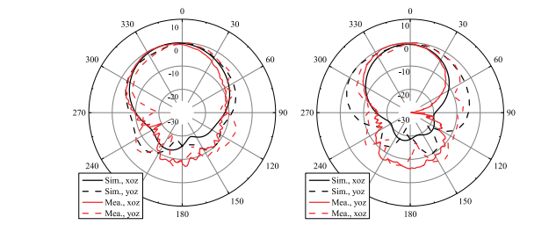

Fig. 14 Radiation Pattern (Gain Total) in the paper

(Left: 9.6GHz; Right:10.4GHz)



Fig. 15 Radiation Pattern (Gain Total) In our model

(Left: 9.3GHz; Right:10.2GHz)

As can be seen from the figure 14&15, the simulation results of our simulated radiation graph at two resonant frequency points(9.6GHz and 10.4GHz) are basically consistent with those in the paper.

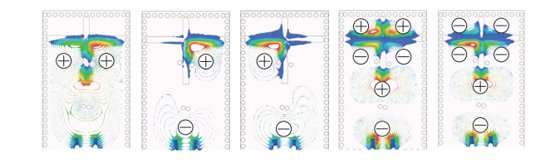

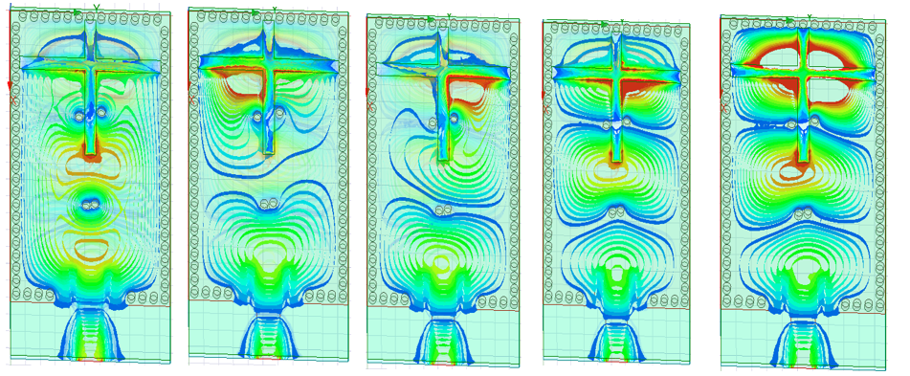

Figure16. Electric field distribution

From left to right,

Freq. :8.9,9.4,9.8,10,6 and 10.9 GHz

Mode: half-TE110, Two hybrid mode (half-TE210 and half-TE120 mode),

odd TE310 and even TE310

As can be seen from the figure16, the simulation results of the electric field distribution of the penta-resonant modes shows that there are a few details that are different from the figure in paper, particularly where the red intensity peaks in the 9.4GHz and 9.8GHz appear opposite. In fact, this slightly inconsistent result is easy to understand: Since the shorting vias around the rectangular patch in our simulation are symmetric, which is slightly different from the author's model. Therefore, the simulated electric field distribution is different. Of course, it is also possible that the simulation results are in the opposite direction due to the different modeling angles between us and the author. However, these two images can already illustrate the problem -- at 9.4GHz and 9.8GHz, penta-mode antenna split the original half-TE210 mode into two hybrid resonant modes, which increases the antenna bandwidth compared to quad-mode antenna.

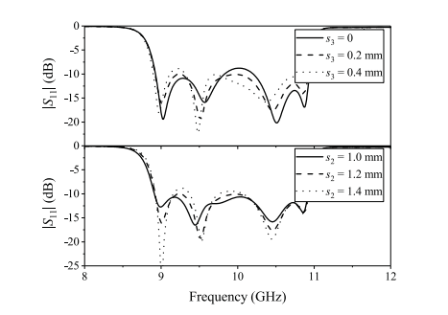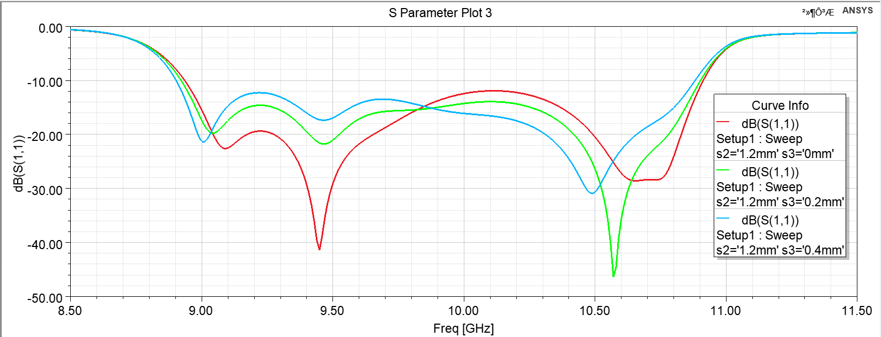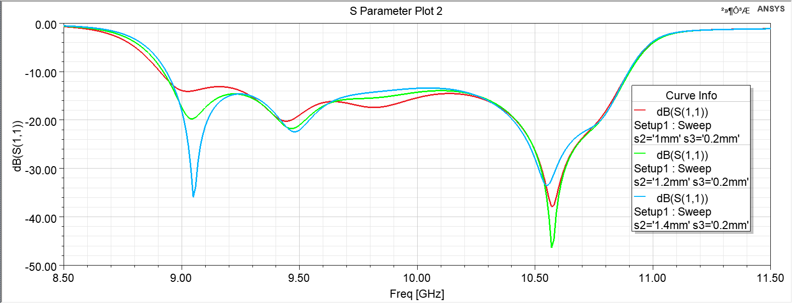

Fig. 17 Figure. Reflection coefficient with varying values of s2 and s3

Above: Result in paper

Below: Result in our work (**Top: s3 changed Bottom: s2 changed**))

As can be seen from the above simulation results (Fig 17), slight differences in S11 caused by changes in S2 and S3 are basically consistent with the results in the paper. This reflects that our modeling is basically accurate.

# The Exploration of PENTA-MODE SIW CBS ANTENNA

The importance of asymmetric shorting vias and cross-shaped slots in this antennas structure was significant during our modeling. Therefore, we try to further explore the antenna structure to observe the influence of these two parts on the performance of the antenna.

## **The four shorting vias in the middle are symmetrical**

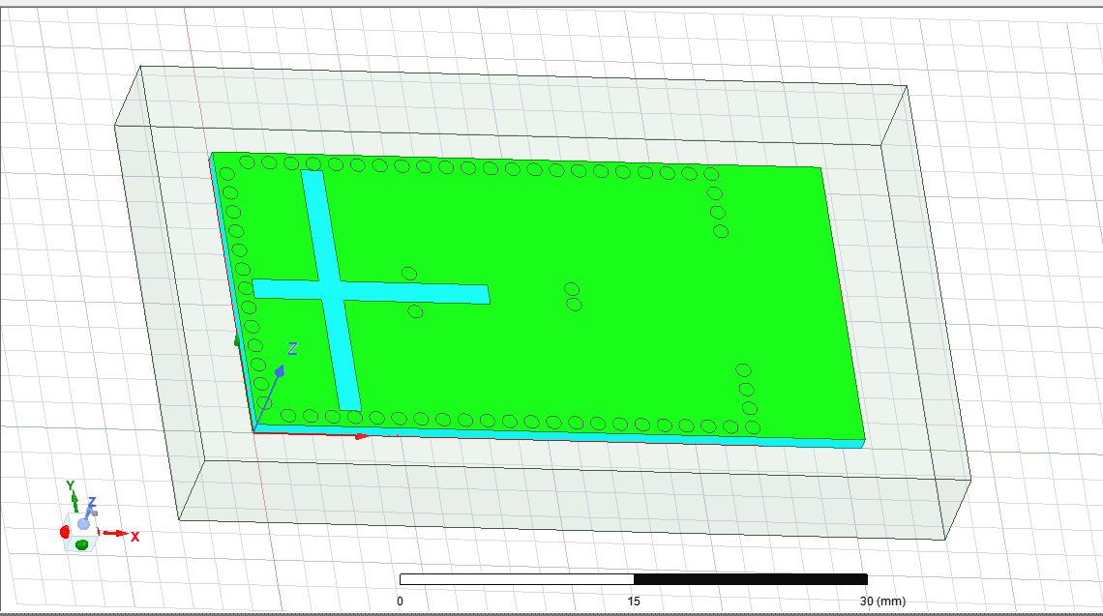

Figure.18. model in A case

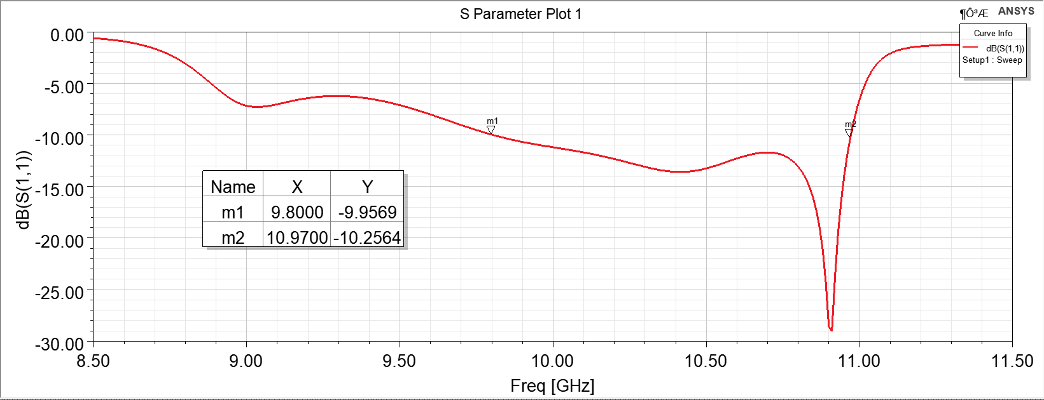

Figure. 19. S11 in A case

It can be seen from the S11 parameter figure that if we make all the four shorting vias in the middle symmetrical, the antenna bandwidth produced is not as good as the asymmetric penta-mode. Therefore, the maximum effect of asymmetric shorting vias is to increase the resonant mode to improve the bandwidth.

## **Two shorting vias in the front are not exist**

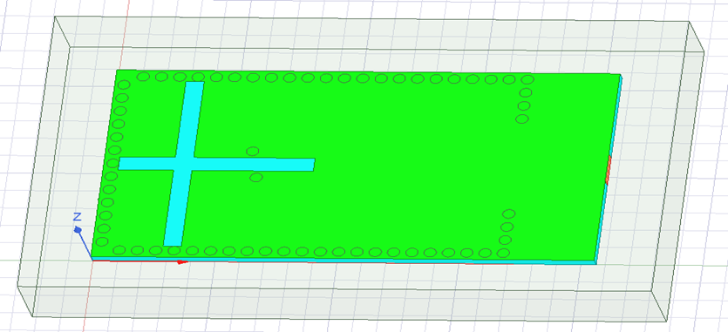

Figure.20. model in B case

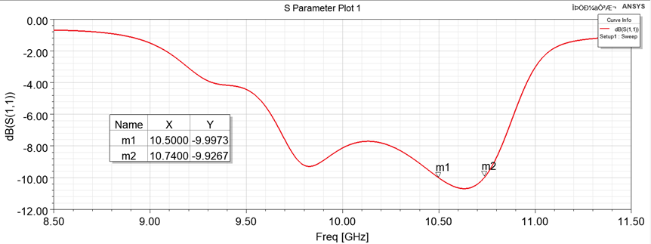

Figure. 21. S11 in B case

According to the S11 parameter in the above figure, if we do not place two asymmetric shorting vias at the front end of the middle part, the bandwidth of the antenna produced is only 0.2GHz, so the maximum effect of two asymmetric shorting vias at the front end of the middle part is to improve the bandwidth of the antenna.

## **All four shorting vias in the middle are not exist**

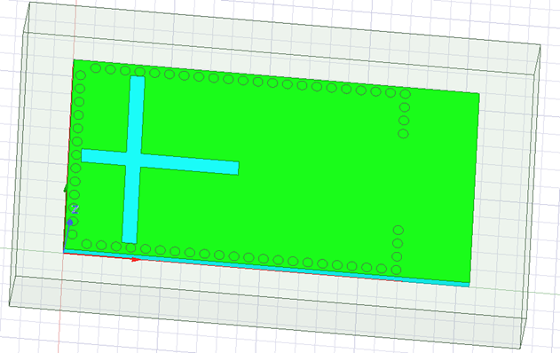

Figure.22. model in C case

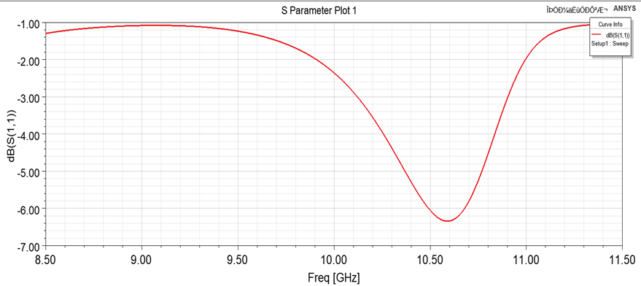

Figure.23. S11 in C case

It can be seen from the S11 parameter figure that if we make all the four shorting vias in the middle symmetrical, the antenna bandwidth produced is not as good as the asymmetric penta-mode. Therefore, the maximum effect of asymmetric shorting vias is to increase the resonant mode to improve the bandwidth. According to the S11 parameter above, we can see that if we do not put any shorting vias on both sides of the cross slot, the S11 parameters will become very large and cannot meet our design requirements. Therefore, the functions of four unbalanced shorting vias on both sides of the cross slot are:

1. Reduce the reflection coefficient of the antenna

2. Add new resonant mode to improve the bandwidth of antenna

## **All shorting vias around the model are not exist**

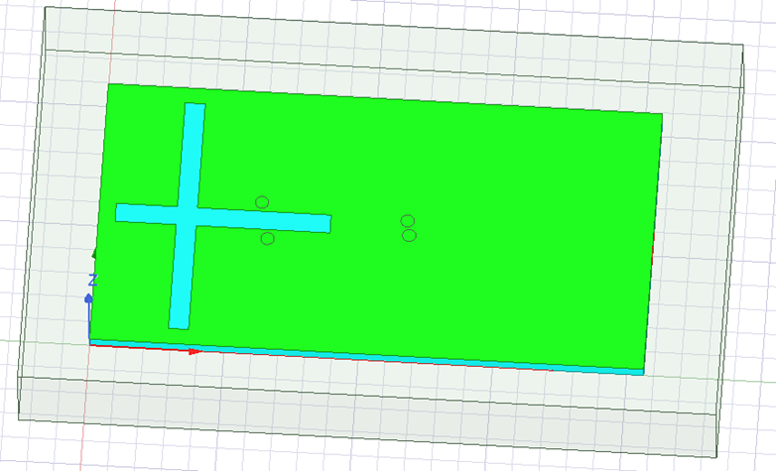

Figure.24. model in D case

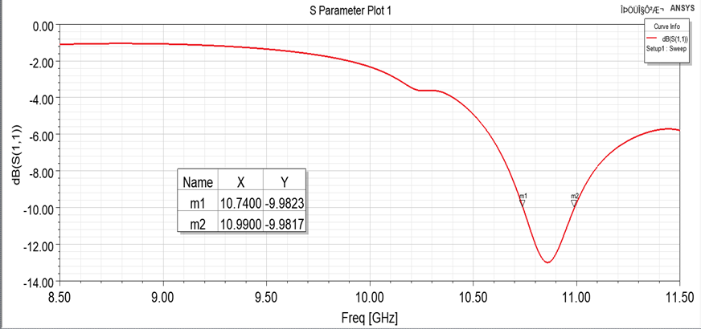

Figure.25. S11 in D case

According to the S11 parameter above, if we do not place shorting vias around the antenna model, the bandwidth of the antenna produced is only 0.25GHz. Therefore, equidistantly placing shorting vias around the patch can improve the bandwidth of the antenna by forming the SIW cavity.

## **All shorting vias have been hollowed out**

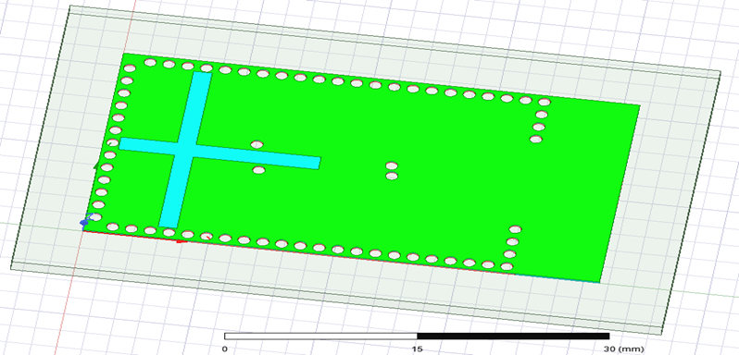

Figure.26. model in E case

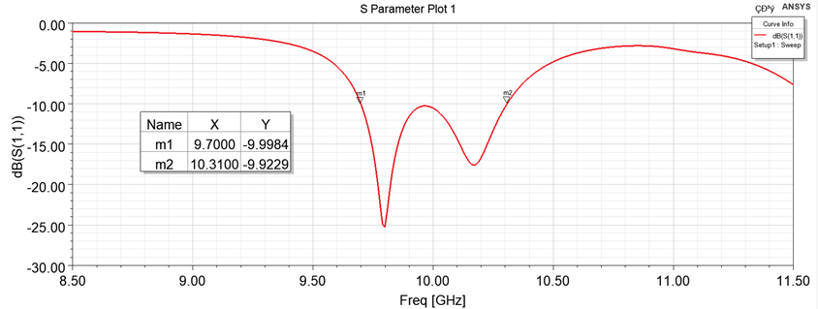

Figure. 27. S11 in E case

According to the S11 parameter above, we can see that if we drill holes, the bandwidth of this antenna is only 0.6GHz. This result is not as good as the bandwidth of penta-mode antenna without perforation.

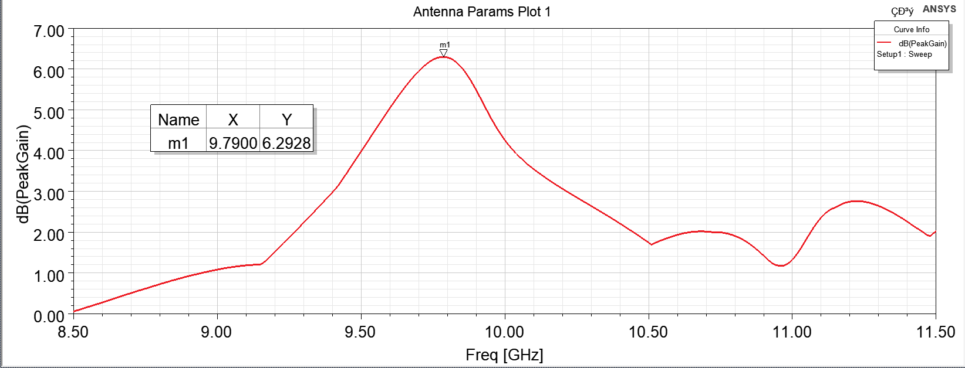

Figure. 28. PeakGain in E case

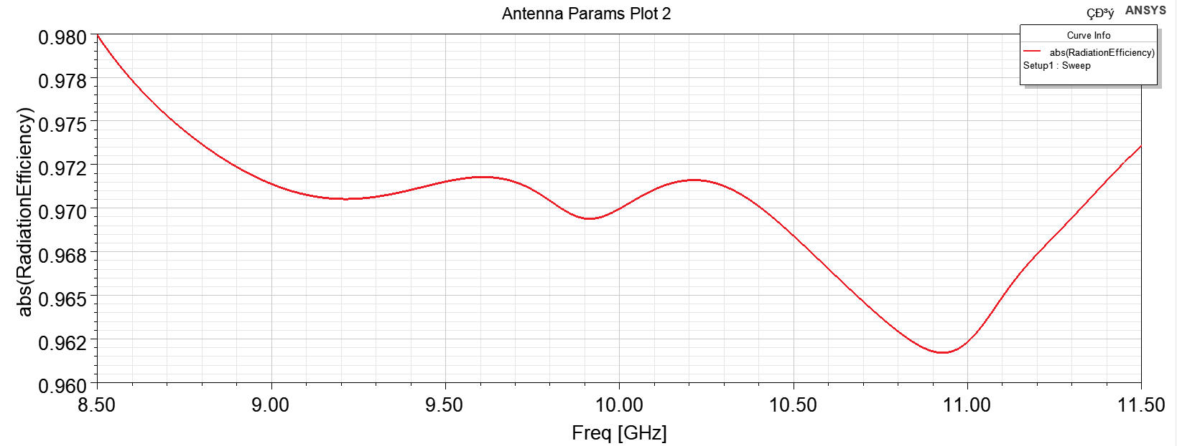

Figure. 29. Radiation Efficiency in E case

Although the bandwidth of the antenna designed in this way is relatively small, the maximum gain and radiation efficiency of this structure are better than that of penta mode without being hollowed out.

## **With Unbalanced shorting vias at boundary**

As we mentioned in the third part, there are some differences between the placement of shorting vias around the patch of the modeling and plate making of penta-mode antenna in the reference paper. The difference in symmetry is shown as follows:

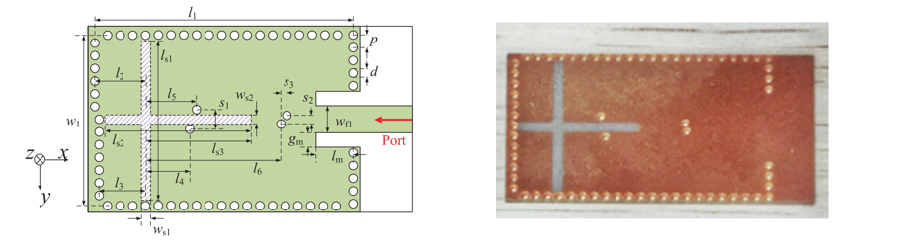

Figure.30. Differences in the placement of shorting vias around the patch

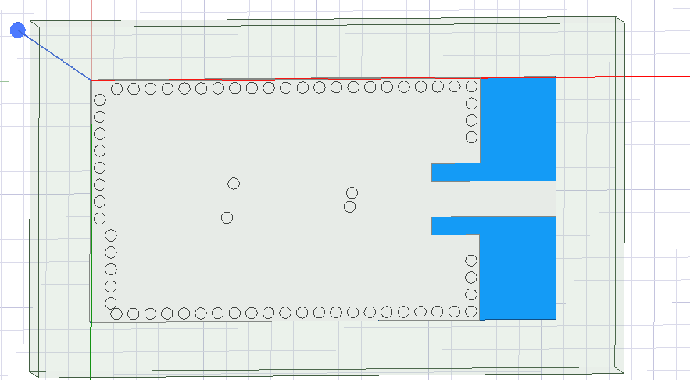

Figure. 31. model in F case

It is worth noting that we have already explored the symmetrical placement of the shorting vias around the patch in detail in part 3, so we will explore the asymmetrical placement of the shorting vias around the patch here.

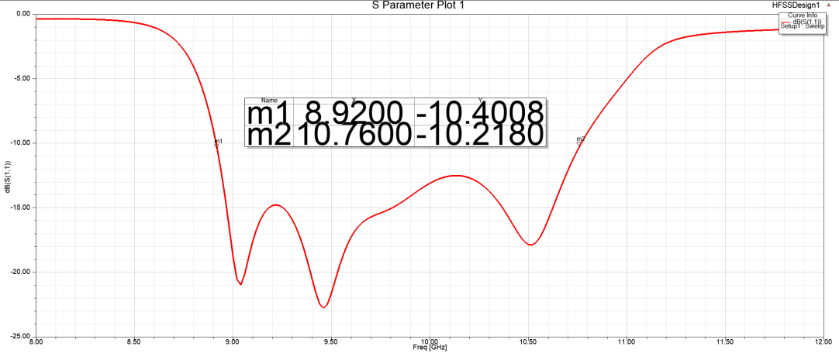

Figure.32. S11 parameter in F case

According to the S11 parameter, we can roughly calculate the antenna bandwidth, which is: 18.7% (8.92–10.76 GHz). However, we can see that the antenna bandwidth simulated by such asymmetrical shorting vias (18.7%) is smaller than the simulation results in the paper (20.8%) and the simulation results of symmetric shorting vias in part3 (20.7%).

In a conclusion, through this part of the exploration, the simulation results of asymmetrically placing Shorting vias around the patch are basically consistent with those of symmetrically placing Shorting vias around the patch in terms of various parameters, but the antenna bandwidth of symmetrically placing Shorting vias around the patch is higher. Therefore, penta-mode antenna with symmetrically placed shorting vias around the patch was used in the final physical production of the paper.

# AnOther Research of QUAD-MODE SIW CBS ANTENNA

In order to make some comparison, we also read another paper [2]and test the performance of its model.

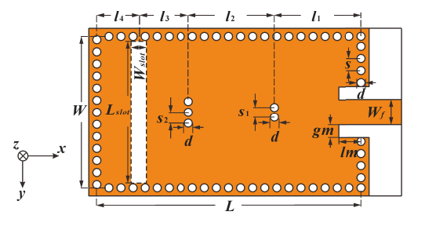

Figure. 33. Model in this paper

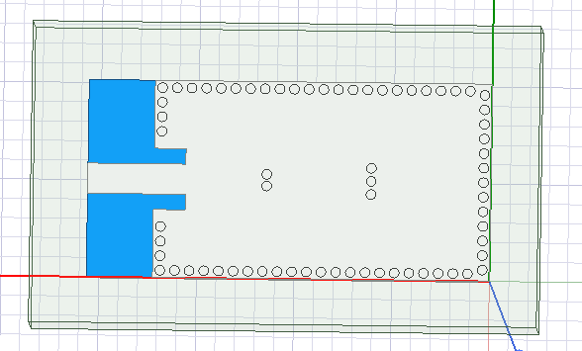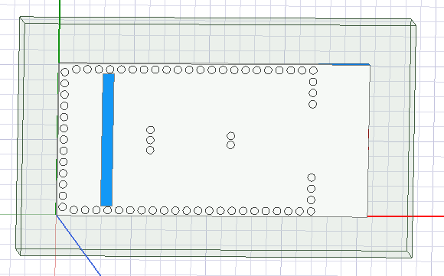

Figure. 34. Our model in HFSS

In this design, a wide bandwidth is also obtained by combining the lowest cavity mode to two higher modes using shorting vias.

However, during our modeling, we find out that the dimension of model paper provides is not consistent with the geometric construction shown in Figure 33. So, we reduce the number of shorting vias on boundary.

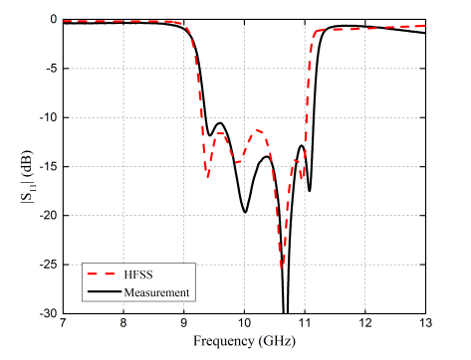

Figure. 35. S11 shown in paper

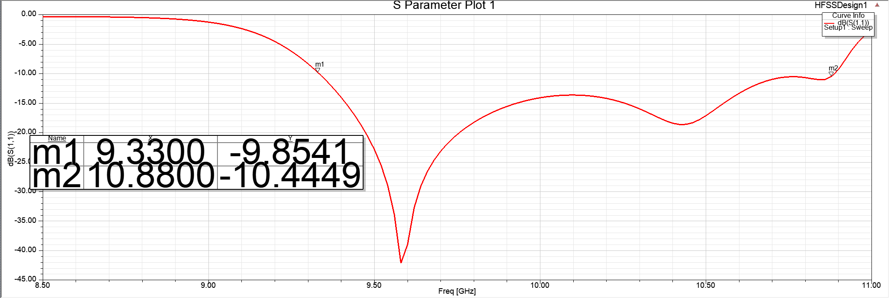

Figure. 36. S11 of our work

According to the Figue35&36, we can roughly measure the antenna bandwidth, which is: 17.5% (9.36–11.26 GHz)

However, we can see that the antenna bandwidth simulated by us is 15.3% (9.33–10.88 GHz), which is smaller. than the result in paper. It may due to the dimension inconsistency we mentioned in previous paragraph. Whatever reason it is, we can still make sure that its BW is smaller than previous quad-mode model.

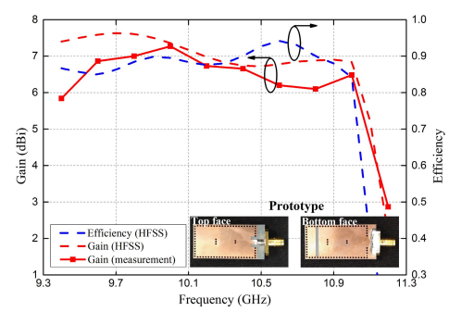

Figure. 37. Gain and efficiency shown in paper

In paper,peak gain is 7.27 dBi and there is a gain variation of within 1.5 dB from 9.4 to 11 GHz; peak value of radiation efficiency is 94.2% at 10.6 GHz

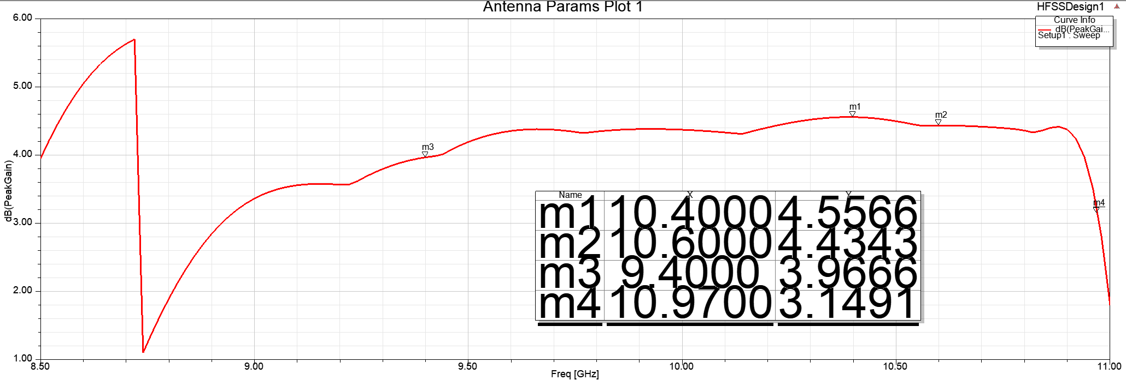 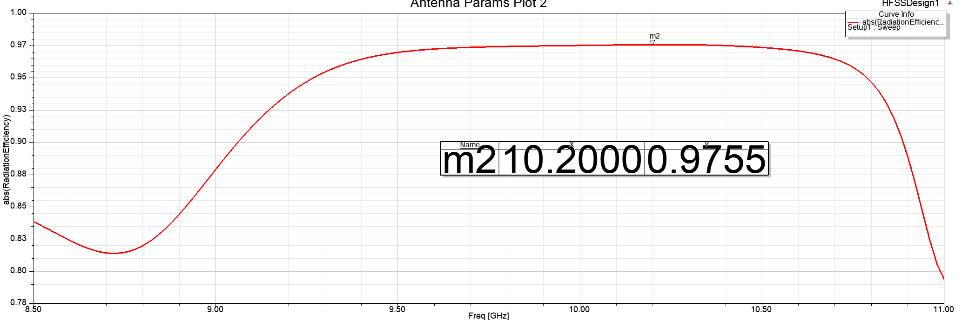

Figure. 38. Gain and efficiency shown in our work

In our work, peak gain 4.55 dBi and there is a gain variation within 1.5 dB from 9.4 to 10.97 GHz; peak value of radiation efficiency is 97.55% at 10.2 GHz. The peak value of gain is smaller than paper’s model. But the stability of gain and efficiency during working BW is good.

# Conclusion

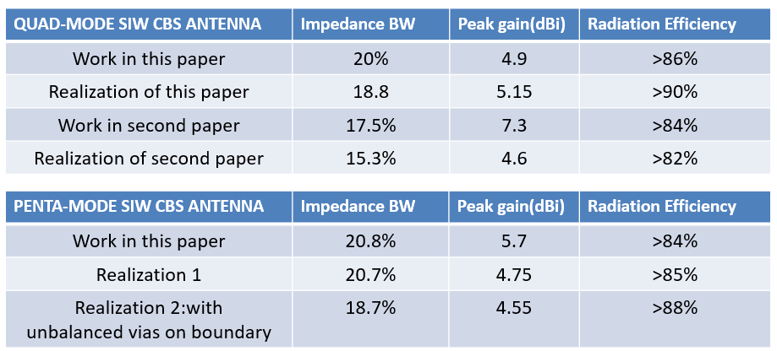

## For broadband applications, two types of planar slot antennas based on SIW cavities have been proposed. First, a quad-resonance SIW CBS antenna has been proposed by combining two coupled unbalanced via-loaded HMSIW CBS antennas to achieve the bandwidth of 20.0%. Second, a penta-resonance SIW CBS antenna has been designed with the bandwidth of 20.8%. Additional modes excited by the cross-shaped slots and the loading vias have been investigated, manipulated, and utilized to support the broad operating bandwidth of the proposed antennas. Simulation results and comparisons show that the proposed SIW CBS antennas do provide excellent features, including broad bandwidth, low profile, broad gain bandwidth, and stable radiation within the operating bandwidth.

References

1. Q. Wu, J. Yin, C. Yu, H. Wang and W. Hong, "Broadband Planar SIW Cavity-Backed Slot Antennas Aided by Unbalanced Shorting Vias," in IEEE Antennas and Wireless Propagation Letters, vol. 18, no. 2, pp. 363-367, Feb. 2019, doi: 10.1109/LAWP.2019.2891108.
2. Y. Shi, J. Liu and Y. Long, "Wideband Triple- and Quad-Resonance Substrate Integrated Waveguide Cavity-Backed Slot Antennas With Shorting Vias," in IEEE Transactions on Antennas and Propagation, vol. 65, no. 11, pp. 5768-5775, Nov. 2017, doi: 10.1109/TAP.2017.2755118.

1.